Supplementary material

SCORE2-OP risk prediction algorithms: estimating incident cardiovascular event risk in older persons in four geographical risk regions

Contents List
Page
Supplementary Methods 3
Supplementary Table 1: Endpoint definitions 17
Supplementary Table 2: Age- and sex-standardized CVD mortality rates per country 18
Supplementary Table 3: Age-, sex-, and region-specific multiplication factors for fatal to total CVD events 19
Supplementary Table 4: Age- and sex-specific multiplication factors for CVD events incl. heart failure 20
Supplementary Table 5: Regional risk factor levels and incidence rates used for recalibration 21
Supplementary Table 6: Comparison between SCORE2-OP and ASCVD risk engine 22
Supplementary Table 7: Comparison of time-dependent ROC and Harrell’s C-statistic 23
Supplementary Figure 1: Distribution of countries in risk regions 24
Supplementary Figure 2: The relative effect of risk factors at different ages 25
Supplementary Figure 3: Calibration plots of observed versus estimated risks within CONOR 26
Supplementary Figure 4: Cardiovascular mortality and incidence in all risk regions 27
Supplementary Figure 5: Estimated CVD incidence rates and predicted risks 28
Supplementary Figure 6: Calibration plots of observed versus estimated risks for external populations 29
Supplementary Figure 7: Age- and sex-specific distributions of CVD risk in the four risk regions 30
Supplementary Figure 8: Risk charts of 5-year risk in all four risk regions 31
Supplementary Figure 9: SCORE2-OP predicted risks for given risk factors in all European regions 35
Supplementary Figure 10: Risk charts of 10 year risk in all risk regions with uncertainty bounds 36
References used in Supplementary Material 40

Supplementary Methods

1.1 Model derivation study population
Cohort of Norway (CONOR) is a collaboration between several population based regional health surveys in Norway carried out between 1994 and 2003. The data collection followed a standard procedure. Participants underwent a simple physical examination and a non-fasting blood sample was drawn at the screening site. Participants filled in one or more questionnaires about their health and disease, family history of disease, use of medication and lifestyle ¹.
Cardiovascular endpoints were obtained through the CVDNOR project (CVDNOR) project (https://cvdnor.b.uib.no) ^{2,3}. The CVDNOR project is a collaboration between the University of Bergen and the previous Norwegian Knowledge Centre for the Health Services, now part of the Norwegian Institute of Public Health. CVDNOR includes information from cardiovascular-related discharge diagnosis [International Classification of Disease (ICD)-9 codes 390-459 or ICD-10 codes I00-I99)] retrieved from the electronic patient administrative systems (PAS) of all Norwegian hospitals from 1994 through 2009. The project obtained date and cause of death from the Cause of Death Registry and information about hospital stays 2008-2014 from the Norwegian Patient Registry. CONOR was linked to the endpoint registries by means of the personal identification number unique for each resident in Norway and this leads to high level of complete outcome registration of both fatal and non-fatal events ^{4,5}.
The Regional Ethics Committee approved the baseline health surveys and follow-up record linkages. The participants have signed a written informed consent for research and linkage of health registries.

Selmer et al. have previously used the linked CONOR data in the development of a Norwegian cardiovascular risk model (NORRISK2) which is included in the Norwegian guidelines for prevention of cardiovascular disease ⁶. Furthermore, the CONOR study has previously been used for model derivation for SCORE O.P., using only the fatal CVD endpoint ⁷.

1.2 External validation study populations

ARIC
This study is a cross-sectional analysis, using data from visit 6 (2016–2017) of the ARIC study, which was originally designed to investigate the natural history of atherosclerotic disease from mid- to late-life. 15,792 participants were recruited during 1987–1989 from four communities in the United States (Forsyth County, NC; Jackson, MS; Minneapolis, MN; and Washington County, MD) and completed the first study visit (visit 1). The participants subsequently completed six study visits (visit 2 in 1990–1992, visit 3 in 1993–1995, visit 4 in 1996–1998, visit 5 in 2011–2013, visit 6 in 2016–2017, and visit 7 in 2018–19). Additionally, they were contacted annually (semiannually, beginning in 2012) to obtain updated information on medical history and lifestyle. For the current study, baseline data collected at visit 5 were used, including assessment for cardiovascular disease and risk factors including laboratory testing. The ARIC study was approved by the institutional review board of each participating center, and written informed consent was obtained from participants at each study visit. Further details on ARIC study design have been described elsewhere ⁸.

CPRD
We used data from the UK Clinical Practice Research Datalink (CPRD) that were linked to Hospital Episode Statistics (HES) inpatient data, and Office for National Statistics (ONS) mortality data. The CPRD database prospectively collects primary care records from consenting general practitioners across the UK. Approximately 7% of the UK population are represented in the database. CPRD obtained approval from a national research ethics committee for researchers to use deidentified data for observational research subject to the approval of a study protocol from the Independent Scientific Advisory Committee. Approximately 80% of CPRD practices registered in England have consented to their patients’ primary care records being linked to other data sources. HES records include all National Health Service–funded inpatient hospitalizations in England since 1997, including diagnoses and procedures. ONS-linked mortality data contain the underlying cause of death, recorded on the death certificate, along with up to 15 other recorded causes of death. The data requested for this study covers the period 2006 to 2017 and participants could be enrolled in the study at any time between these years. Further details on CPRD study design have been described elsewhere ⁹.

HYVET
HYVET was a double blind placebo controlled trial of an antihypertensive regimen (thiazide-like diuretic, indapamide 1.5 sustained release, with the optional addition of an angiotensin converting enzyme inhibitor, perindopril 2–4 mg) in those aged 80 and over. Participants with hypertension (mean systolic BP 160–199 mm Hg and a standing systolic BP ≥140 mm Hg) were recruited between February 2001 and October 2007 from over 90 primary and secondary care centres in 13 countries and randomised to receive trial treatment or matching placebo. All required ethical approvals were obtained. Participants were seen during a 2-month placebo run-in phase, at baseline, every 3 months during the first year and every 6 months thereafter. Trial endpoints were reported as they occurred and included death, stroke, myocardial infarction, and incident or worsening heart failure. Validation of trial endpoints was carried out by a trial endpoint committee of international experts blinded to trial treatment allocation and with full access to supporting documentation, for example, death certificates, hospitalization reports etc. Median follow-up was 1.8 years, after the study was stopped preliminary at second interim analysis due to a significant reduction in all-cause mortality in the active treatment arm. Full details of the HYVET protocol have been published elsewhere ¹⁰.

MESA
MESA is a multi-ethnic, community-based, multiethnic prospective cohort study of 6,814 men and women of 4 self-identified racial/ethnic groups (non-Hispanic whites, African American, Hispanic, or Chinese American). MESA participants were recruited between 2000 and 2002 in 6 field centers: Wake Forest University in Winston-Salem, NC; Columbia University in New York, NY; The Johns Hopkins University in Baltimore, MD; University of Minnesota in Minneapolis; Northwestern University in Chicago, IL; and University of California in Los Angeles. The age range at baseline was 45 to 84 years, and participants had to be free of clinically overt atherosclerotic cardiovascular conditions to be eligible for inclusion. All study participants provided written informed consent at each examination, and study protocols were approved by site-specific Institutional Review Boards at respective MESA-participating institutions. Further details on the MESA study design have been described elsewhere ¹¹.

PROSPER
The PROSPER trial is a large, prospective multicenter randomized clinical trial that assessed whether treatment with pravastatin diminishes the risk of major vascular events in older individuals from three countries (the Netherlands, Scotland, Ireland). Between December 1997 and May 1999, 5804 men and women aged 70–82 years were enrolled if they had pre-existing vascular disease or increased risk due to smoking, hypertension, or diabetes. Participants with the following conditions were not recruited in the PROSPER study: congestive heart failure; significant arrhythmia; cognitive impairment (Mini-Mental Score Examination score <24). Included participants were randomly assigned to either pravastatin or placebo for an average 3.5-year intervention period. The full methodology of PROSPER has been described in more detail elsewhere ¹².

SPRINT
The design, eligibility, and baseline characteristics of SPRINT have been described elsewhere ^{13,14}. SPRINT was a randomized, controlled, open-label trial that was conducted at 102 clinical sites (organized into 5 clinical center networks) in the United States. The trial protocol was approved by the institutional review board at each participating site. Study participants were required to be at increased risk for cardiovascular disease. A person was excluded if he or she had type 2 diabetes, a history of stroke, symptomatic heart failure within the past 6 months or reduced left ventricular ejection fraction (<35%), a clinical diagnosis of or treatment for dementia, an expected survival of less than 3 years, unintentional weight loss (>10% of body weight) during the preceding 6 months, an SBP of less than 110 mm Hg following 1 minute of standing, or resided in a nursing home. Sociodemographic data were collected at baseline, whereas both clinical and laboratory data were obtained at baseline and every 3 months. Eligible participants were assigned to a systolic blood-pressure target of either less than 140 mm Hg (the standard-treatment group) or less than 120 mm Hg (the intensive-treatment group). For the current study, patients aged 65 years or older were included between November 2010 and March 2013. To investigate the effect of blood pressure lowering therapy in older persons, a subgroup of elderly aged 75 years or older was pre-specified in the study design and, as such, well-represented within the study population ¹⁴.
A committee unaware of treatment assignment adjudicated the protocol-specified clinical outcomes. The primary cardiovascular disease outcome was a composite of nonfatal myocardial infarction, acute coronary syndrome not resulting in a myocardial infarction, nonfatal stroke, nonfatal acute decompensated heart failure, and death from cardiovascular causes. Secondary outcomes included all-cause mortality and the composite of the SPRINT primary outcome and all-cause mortality. In August 2015, the trial was ended preliminarily after interim analysis, after a median follow-up of 3.3 years.

1.3 Model development (adapted from Hageman et al. ¹⁵)
The interlinked stages of model development, including model derivation and recalibration are summarised in Supplementary Methods Figure 1. An overview of the process as follows: Fine and Gray models were derived using data from CONOR (Box 1). Four geographical risk regions were defined according to the age-standardized country-specific cardiovascular mortality rates. For each region, annual age- and sex-specific mortality rates were then translated to 10-year mortality risk estimates, allowing for competing risk of non-CVD death (Box 2). In order to translate 10-year mortality to 10-year risk of fatal and non-fatal CVD, region- age- and sex-specific multiplication factors were estimated using representative registry data and cohorts from each risk region. Multiplication factors were defined as the ratio between the cumulative incidence of fatal and non-fatal CVD events and the cumulative incidence of fatal CVD (Box 3). Multipliers were then used to translate region, sex and age specific 10-year mortality incidence to expected 10-year risk of fatal and non-fatal CVD events (Box 4). Region, sex and age-specific predicted 10-year risks were then estimated using the core, un-calibrated 10-year risk models (derived in Box 1) with region, sex and age-specific risk factors from the Non-Communicable Disease Risk Factor Collaboration (NCD-RisC) (Box 5). The region and sex and age-specific predicted risks (from Box 5) were compared to expected risks (from Box 4) and rescaling factors were estimated to recalibrate the models for each region and sex (Box 6). Finally, the rescaling factors are applied with the original un-calibrated model to give new, recalibrated risk predictions in new individuals (Box 7).

The methods applied in Boxes 1, 2, 3 and 6 warrant further explanation and are detailed as follows:

Box 1: Model derivation
For model derivation, sex-specific coefficients were estimated using Fine and Gray competing risk-adjusted models. Risk predictors were age, sex, current smoking, history of diabetes mellitus, systolic blood pressure, and total and HDL cholesterol and age-interactions were added for all predictors. Continuous risk predictors were centred before analysis. There were no or minimal violations of the proportional hazards assumptions as assessed visually based on plotted Schoenfeld residuals.

Box 2: Estimation of 10-year competing risk adjusted mortality for each risk region
Estimates of CVD event incidence were based on the most recent WHO cardiovascular mortality rates, which were transformed to estimates of CVD event incidence using a multiplier approach. WHO cause-specific mortality rates are supplied by every country and coded in ICD-9 or ICD-10. Rates included mortality from all causes included in the original SCORE endpoint ¹⁶ (Supplementary Table 1). Non-CVD mortality was defined as all mortality from causes not included in the SCORE endpoint.
For every age-group, CVD mortality rates were used which were observed at the midpoint of the projected 10-year follow-up period, so the CVD mortality rates of one 5-year age-group ahead (i.e. for prediction in the 40 to 44 year age-group the rates for 45 to 49 years were used as these are at the midpoint of the 10-year interval). WHO rates of both the fatal cardiovascular outcome and the competing outcome non-CVD mortality were converted to 1–year mortality risks ($r)$ using the following formula:
$$r=1- e^{(-fatal rate)}⁡$$
The 1-year risks of fatal CVD were corrected for the competing risk of non-CVD death and extrapolated to 10-year risks. This was done using life-tables with 1-year intervals, using follow-up time as a timescale ^{17,18}. For every interval, CVD-free survival was calculated using the following formula:
$$S_{t+1}= S_{t}×(1-r_{cvd,t}-r_{comp,t}).$$
In which S_{t}=probability of being alive at start of interval t; S_{t+1}=probability of being healthy and alive at end of interval t; and $r_{cvd,t}$ and $r_{comp,t }$ are the probabilities of experiencing a fatal CVD event or competing events respectively during interval t, given disease-free survival up to start of interval t; For each 1-year interval of the 10-year timeframe of interest, the cause-specific CV mortality risk was calculated using:
$${CVrisk}_{t}=\frac{r_{cvd,t}}{r_{cvd,t}+r_{comp,t}}* {(S}_{t}-S_{t+1})$$
The 10-year cumulative cause-specific risk was calculated as the sum of the 1-year cause-specific risks:
$${CVrisk}_{t1-10}= \sum_{1-10}{{CVrisk}_{t}}$$

Box 3: Estimation of Multipliers to convert mortality to incidence estimates in each risk region
To convert 10-year mortality estimates to incidence estimates, age- and sex-specific multiplication factors were defined as:
$$\frac{{Cumulative 10 year incindence total CV events}_{without prior CVD}}{{Cumulative 10 year incindence fatal CV events}_{entire population}}$$
These allowed the population level mortality statistics, which are calculated among the whole population, regardless of prior disease status, to be converted into first event incidence estimates, representative of the target primary prevention population (those without prior CVD). Multiplication factors were derived in Clinical Practice Research Datalink ⁹ (CPRD; n = 2,589,074) for the low risk region, the Swedish Patient Registry ¹⁹ for the moderate risk region (n = 5,252,592), the Estonian biobank ²⁰ (n = 67,474) for the high risk region, and the HAPIEE study ²¹ (Lithuania + Russia, n = 16,521) for the very high risk region. In each cohort and sex, two Fine and Gray models, adjusted for baseline age and age-squared were fit: one modelling 1st CVD event as the outcome and using only individuals without prior CVD, and one with fatal CVD as the outcome and including all participants (regardless of prior disease). The relevant cumulative 10-year incidence was then estimated using each model, for each age group, and age group-specific 10-year CVD event risk was then estimated as follows:
$${CVDrisk}_{total, 10}=\frac{{Cumulative incindence fatal+nonfatal CV events}_{without prior CVD}}{{Cumulative incindence fatal CV events}_{General population}}* {CVrisk}_{t1-10}$$
Multiplication factors were assumed to be stable within each region and over time ¹⁵. To aggregate the multipliers from the different cohorts to a single set of multipliers for the low/moderate and for the high/very high risk regions, the mean was calculated of all relevant multipliers, weighted by the size of the multiplier-derivation cohort. The region-, age- and sex-specific multipliers can be found in Supplementary Table 4. Age and sex-specific 10-year mortality CVD rates and derived incidence rates are shown for each region in Supplementary Figure 4. The age-specific and sex-specific estimated CVD event rates used for recalibration are presented by region in Supplementary Table 5.

Box 6: Relate expected to predicted risks to calculate rescaling factors for model recalibration
Recalibration of the core SCORE2-OP model was performed separately for each geographical risk region, using a previously described methodology, which is summarized in Supplementary Methods Figure 2 ^{15,22}. This involved the use of regional age- and sex-specific mean risk factor levels (from NCD-RisC) and age- and sex-specific estimates of expected cumulative 10-year risk, estimated as described above. We used the core SCORE2-OP risk models to estimate 10-year predicted risk of the endpoint for each of the age groups using the mean risk factor values. Having completed this process for each age group, as shown in Figure 2 we then regressed transformed expected 10-year risk across age groups on that predicted by the core SCORE2-OP models to derive recalibration factors (the intercept and slope of the resulting regression line, Supplementary Methods Table 1). The SCORE2-OP risk models, rescaled using the recalibration factors were then used to estimate appropriate risks for each potential risk factor combination, for a new individual or for formation of the example risk charts.

A stepwise approach for how to estimate individualized 10-year CVD event risk estimations can be found in Supplementary Methods Table 2, with individual example calculations shown in Supplementary Methods Table 3.

1.4 Missing data
Because complete case analysis may lead to loss of statistical power and possible bias, values of predictors were imputed by single regression imputation with predictive mean matching for all cohort data. As the CPRD consists of care-as-usual data, missing data was much more frequent and missingness was more likely to correlate with cardiovascular disease risk. Therefore, multiple imputation was performed for the external validation in CPRD with fully conditional specification using 5 imputed datasets.

1.5 Uncertainty of risk predictions
In clinical practice, clinical decision are made based on the best available evidence. In risk prediction, this is the point estimate as estimated with the risk model. However, it is good to realize that there is uncertainty around these point estimates. To calculate confidence intervals surrounding individual predicted risks based on the uncertainty of all model coefficients, risk predictions were repeated with the lower or upper bounds of the confidence intervals of all beta coefficients (Table 2). In Supplementary Figure 8 the uncertainty around the point estimates is presented in risk charts.

1.6 Predicting treatment effects from risk factor treatment using SCORE2-OP
It has previously been shown that risk estimations can be combined with relative treatment effects from trials to calculate absolute individualized treatment effects ¹⁸.
To show the potential use of using SCORE2-OP in daily practice, we included analyses on the individual absolute benefit of blood pressure lowering and lipid lowering in older persons. To estimate the effect of blood pressure lowering on CVD, average relative treatment effects were added to SCORE2-OP, using a hazard ratio (HR) of 0.80 per 10 mmHg SBP reduction taken from a large meta-analysis for blood pressure lowering ²³, and estimating the benefit from the reduction of office SBP to the target of <140mmHg for persons with hypertension at baseline (SBP >140 mmHg) from the HYVET and SPRINT trials (both blood pressure lowering trials ^{13,24}). For lipid lowering, an HR of 0.78 per 1 mmol/L LDL reduction was used ²⁵, and the treatment benefit of lowering LDL cholesterol to < 2.6 mmol/L was estimated for all patients with an LDL cholesterol >2.6 mmol/L from the PROSPER trial (a lipid lowering trial ¹²). For both treatment effects, it was assumed that the HR can be applied across the entire age range. Indeed, no evidence for heterogeneity of these treatment effects across different age ranges has been found ^{23,26,27}.
First, we tested the assumption that the same relative treatment effect can be used in all individuals by making a Cox model in respectively the HYVET, SPRINT, and PROSPER study populations including a “model linear predictor * trial allocation” interaction term ²⁸.
Then treatment benefit was calculated for the respective risk factor treatment by combining the hazard ratio with the individualized estimated 10-year CVD event risk (here shown for SBP reduction):
$${Risk}_{with treatment}=1-{{(1-risk}_{original}}^{\exp\left(\log\left(HR\right)×(\frac{SBP reduction}{10})\right)})$$
Treatment benefit for individual patients is defined as the absolute risk reduction (ARR) from treatment:
$$ARR=\left({risk}_{original}-{risk}_{with treatment}\right)*100$$

Histograms were constructed showing the distribution of treatment effects from blood pressure lowering in the combined study population from the HYVET and SPRINT trials (Figure 4), and from lipid lowering in the PROSPER trial (Figure 5), respectively.

Supplementary Methods Table 1: Region-specific rescaling factors
 | Men |  | Female
 | Scale 1 | Scale 2 | Scale 1 | Scale 2
Low risk region | -0.34 | 1.19 | -0.52 | 1.01
Moderate risk region | 0.01 | 1.25 | -0.1 | 1.1
High risk region | 0.08 | 1.15 | 0.38 | 1.09
Very high risk region | 0.05 | 0.7 | 0.38 | 0.69

Rescaling factors for the SCORE2-OP model to scale predicted risks to the target population in very risk region, based recent nationally representative estimates of incident cardiovascular disease and risk factor levels.

Supplementary Methods Table 2: A stepwise approach to estimating 10-year CVD risk for an individual patient
Calculate 10-year CVD event risk
1. Calculate individual model linear predictor (LP) | LP = ∑β_{sex-specific} * (x - x_{cen})  Where:  β_{sex-specific} are the sex-specific coefficients (Table 2),  x is the individual person value of the predictor  x_{cen} is the value at which each predictor was centered: age = 73, SBP = 150; total cholesterol = 6; HDL cholesterol =1.4.
2. Calculate the original (or unrecalibrated) 10-year risk (θ_{original}) | θ _{original} = 1 – basesurv_{sex-specific}^exp(LP – meanLP_{sex-specific})  Where:  Basesurv_{sex-specific} is the sex-specific 10-year baseline survival for an average patient: for men, 0.758; for women, 0.808  meanLP is the sex-specific mean linear predictor: for men, 0.093; for women, 0.229
3. Use the age-, sex-, and region-specific rescaling factors from Supplementary Methods Table 1 to calculate the recalibrated 10-year risk for your individual patient (θ) | θ = 1 – exp(-exp(Scale1 + Scale2 x ln(-ln(1- θ _{original}))))  Multiply by 100 to get your individual 10-year risk as a percentage.
Calculate 10-year risk of CVD events incl. heart failure
Include the multiplication factor from Supplementary Table 4 in step 2, the rest of the procedure is identical | θ _{original} = 1 – basesurv_{sex-specific}^exp(LP – meanLP_{sex-specific} - ln(multiplier_{age,sex}))  Where:  Multiplier_{age,sex} is the age- and sex-specific multiplier

Supplementary Methods Table 3: Example calculations for the estimated CVD event risk for an individual patient using SCORE2-OP
Calculation of estimated 10-year CVD event risk using SCORE2-OP
Individual risk factor levels | Model coefficients (women) |  | Calculation of 10-year CVD event risk using SCORE2-OP
Sex = female  Age = 75  Total cholesterol = 5.5  HDL cholesterol =1.3  SBP = 140mmHg  Diabetes = No  Smoking = Yes | Age (per year) | 0.0789 | $\sum{β(x-x_{cen})}$ = 0.0789 x (75-73)  + 0.6010 x 0  + 0.4921 x 1  + 0.0102 x (140-150)  + 0.0605 x (5.5-6)  - 0.3040 x (1.3-1.4)  - 0.0107 x (75-73) x 0  - 0.0255 x (75-73) x 1  - 0.0004 x (75-73) x (140-150)  - 0.0009 x (75-73) x (5.5-6)  + 0.0154 x (75-73) x (1.3-1.4)  = -0.5029  Unrecalibrated (original) risk:  10-yr risk = 1-0.8082^exp($\sum{β}\left(x-x_{cen}\right)-0.229)$  = 1-0.8082^exp(0.5029 – 0.229)  = 0.2442 = 24.4%  Recalibrate to low risk region:  10-yr risk = 1-exp(-exp(-0.85+0.82 x ln(-ln(1- original risk))))  = 1-exp(-exp(-0.85+0.82 x ln(-ln(1- 0.2442))))  = 0.1397 = 14%
 | Diabetes | 0.6010
 | Smoking | 0.4921
 | SBP (per mmHg) | 0.0102
 | Total cholesterol (per mmol/L) | 0.0605
 | HDL cholesterol (per mmol/L) | -0.3040
 | Diabetes interaction with age | -0.0107
 | Smoking interaction with age | -0.0255
 | SBP interaction with age | -0.0004
 | Total cholesterol interaction with age | -0.0009
 | HDL cholesterol interaction with age | 0.0154
Individual risk factor levels | Model coefficients (men) |  | Calculation of 10-year CVD event risk using SCORE2-OP
Sex = male  Age = 75  Total cholesterol = 5.5  HDL cholesterol =1.3  SBP = 140mmHg  Diabetes = No  Smoking = Yes | Age (per year) | 0.0634 | $\sum{β(x-x_{cen})}$ = 0.0634 x (75-73)  + 0.4245 x 0  + 0.3524 x 1  + 0.0094 x (140-150)  + 0.0850 x (5.5-6)  - 0.3564 x (1.3-1.4)  - 0.0174 x (75-73) x 0  - 0.0247 x (75-73) x 1  - 0.0005 x (75-73) x (140-150)  + 0.0073 x (75-73) x (5.5-6)  + 0.0091 x (75-73) x (1.3-1.4)  = -0.3298  Unrecalibrated (original) risk:  10-yr risk = 1-0.7576^exp($\sum{β}\left(x-x_{cen}\right)-0.0929)$  = 1-0.7576^exp(0.3298 – 0.0929)  = 0.2966 = 29.7%  Recalibrate to low risk region:  10-yr risk = 1-exp(-exp(-0.61+0.89 x ln(-ln(1- original risk))))  = 1-exp(-exp(-0.61+0.89 x ln(-ln(1- 0.2966))))  = 0.1930 = 19.3%
 | Diabetes | 0.4245
 | Smoking | 0.3524
 | SBP (per mmHg) | 0.0094
 | Total cholesterol (per mmol/L) | 0.0850
 | HDL cholesterol (per mmol/L) | -0.3564
 | Diabetes interaction with age | -0.0174
 | Smoking interaction with age | -0.0247
 | SBP interaction with age | -0.0005
 | Total cholesterol interaction with age | 0.0073
 | HDL cholesterol interaction with age | 0.0091

Supplementary Methods Figure 1: SCORE2-OP model development process

Supplementary Methods Figure 2: Methods used for recalibration of risk scores

$$θ_{pred,agegroup}=1-{0.7576}^{exp⁡(\sum{β{x-x}_{cen}-0.0929)}}$$
Use population risk factor values to calculate a predicted risk for each age group in the target population using the original equation
θ = 10 year CVD risk
β = SCORE2-OP coefficients
x= age group specific mean risk factor values in the target population
x_{cen} = values at which each risk factor was centered in SCORE2-OP
0.7669 = the 10-year baseline survival
0.1111 = linear predictor at mean risk factor levels for SCORE2-OP
$$θ_{obs, agegroup}$$
Use age group specific mortality statistics from the target population and relevant multipliers to estimate observed 10-year risk for each age group
Estimating using lifetable approach and application of multipliers for each age group (supplementary methods 1)
$$ln⁡(-\ln\left(1-θ_{obs, agegroup})\right)=Scale1+Scale2 x ln⁡(-\ln\left(1- θ_{pred,agegroup})\right)$$
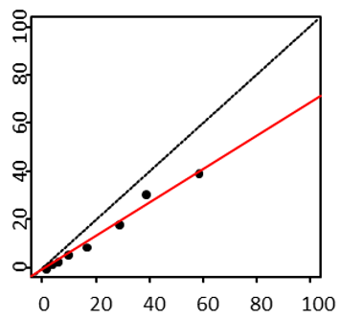

Predicted risk
Observed risk
Each point represents one age group
Fitted line
Line of equality

Calculate rescaling factors needed to bring predicted risks in line with observed risks for the target population
Regress the age-specific observed-on-predicted risks
(note values are first transformed)
Scale1 and Scale2 are the estimated rescaling factors)
General process:
Details/example using SCORE2-OP for men
(A) Calculate original risk estimation for an individual or specific combination of risk factors:
$$θ_{pred}=1-{0.7576}^{exp⁡(\sum{β{x-x}_{cen}-0.0929)}}$$
(B) Use rescaling factors to estimate the recalibrated risk:
$$θ_{newpred}=1-exp⁡(-\exp\left(Scale1+Scale2×\ln\left(-\ln\left(1-θ_{pred})\right)\right)\right)$$

Using rescaling factors to give a recalibrated 10-year risk estimate for each new individual/combination of risk factors
β = SCORE2-OP coefficients
x are the risk factor values, either for a new individual (when using an online calculator) or for a specific entry on the risk charts

Supplementary Table 1: Endpoint definitions
1. Fatal cardiovascular disease– cause specific mortality due to any of the following:
Endpoints included | ICD10-codes
Hypertensive disease | I10-16
ischemic heart disease | I20-25
Arrhythmias, heart failure | I46-52
Cerebrovascular disease | I60-69
Atherosclerosis/AAA | I70-73
instantaneous death and death within 24h of symptom onset | R96.0-96.1
The following ICD codes are to be excluded from the above endpoint:
Myocarditis, unspecified | I51.4
subarachnoid hemorrhage | I60
Subdural hemorrhage | I62
Cerebral aneurysm | I67.1
Cerebral arteritis | I68.2
Moyamoya | I67.5

2. Hospitalization from cardiovascular disease
Endpoints included | ICD10-codes
Non-fatal myocardial infarction | I21-23
Non-fatal stroke | I60-69
Excluded from the non-fatal stroke endpoint:
Subarachnoid hemorrhage | I60
Subdural hemorrhage | I62
Cerebral aneurysm | I67.1
Cerebral arteritis | I682
Moyamoya | I675

Supplementary Table 2: Age- and sex- standardized CVD mortality rates per country

Countries | Age- and sex- standardized CVD mortality rates (per 100,000 persons) | Year collected
Low risk region
France | 70.9 | 2014
Israel | 76.7 | 2015
Spain | 89.4 | 2015
Netherlands | 89.9 | 2016
Switzerland | 90.2 | 2015
Denmark | 90.4 | 2015
Norway | 90.8 | 2015
Luxembourg | 92.9 | 2015
Belgium | 99.2 | 2015
United Kingdom | 99.7 | 2015
Moderate risk region
Iceland | 101.0 | 2016
Portugal | 107.9 | 2014
Sweden | 109.0 | 2016
Italy | 110.1 | 2015
San Marino | -
Ireland | 111.5 | 2014
Cyprus | 111.5 | 2016
Finland | 128.5 | 2015
Austria | 130.9 | 2016
Malta | 133.3 | 2015
USA | 131.8 | 2016
Greece | 138.8 | 2015
Germany | 139.0 | 2015
Slovenia | 143.3 | 2015

Countries without available population or incidence data in the WHO database (indicated by - ) were grouped using rates available from neighboring countries

Countries | Age- and sex- standardized CVD mortality rates (per 100,000 persons) | Year collected
High risk region
Albania | 184.5 | 2010
Czech Republic | 195.0 | 2016
Turkey | 199.5 | 2015
Kazakhstan | 214.0 | 2015
Croatia | 214.6 | 2016
Poland | 223.8 | 2015
Estonia | 234.8 | 2015
Slovakia | 239.2 | 2014
Hungary | 274.1 | 2016
Bosnia and Herzegovina | 279.2 | 2014
Very high risk region
Armenia | 306.3 | 2016
Lithuania | 309.0 | 2016
Georgia | 309.6 | 2015
Latvia | 327.2 | 2015
Serbia | 329.1 | 2015
Romania | 330.5 | 2016
Montenegro | 348.4 | 2009
Russian Federation | 368.8 | 2015
TFYR Macedonia | 387.8 | 2013
Belarus | 395.4 | 2014
Azerbaijan | 416.5 | 2007
Bulgaria | 421.2 | 2014
Republic of Moldova | 442.2 | 2016
Ukraine | 476.7 | 2015
Kyrgyzstan | 476.9 | 2015
Uzbekistan | 478.6 | 2014
Egypt | 543.7 | 2015
Morocco | -
Syria | -
Tunisia | -
Lebanon | -
Algeria | -
Libya | -

Supplementary Table 3: Age- and sex-specific multiplication factors for fatal CVD events to total events in the different risk regions
 | Low/moderate risk region |  | High/very high risk region
Age group | Men | Women | Men | Women
65-70 | 2.6 | 3.2 | 1.6 | 2.5
70-75 | 2.1 | 2.5 | 1.4 | 1.9
75-80 | 1.6 | 1.9 | 1.3 | 1.5
80-85 | 1.3 | 1.5 | 1.1 | 1.4
85+ | 1.1 | 1.1 | 0.9 | 1.0

Multiplication factors for the SCORE2-OP model specific for each age group, sex and region. Multiplication factors were defined as the ratio between the cumulative incidence of fatal CVD and the cumulative incidence of CVD events. Multipliers were used to multiply observed CVD mortality rates in the agegroup stated in this table and are therefore used to recalibrate 10-year risks in one age group below.

Supplementary Table 4: Age- and sex-specific multiplication factors in CONOR for the primary endpoint to secondary endpoint CVD events plus HF
Age group | 65 | 70 | 75 | 80 | 85+
Men | 1.10 | 1.15 | 1.19 | 1.20 | 1.17
Women | 1.14 | 1.20 | 1.22 | 1.22 | 1.20

Supplementary Table 5: Regional risk factor levels and incidence rates used for recalibration
Agegroup | Region | Sex | Systolic blood pressure (mmHg) | Smoking (%) | Total cholesterol (mmol/L) | HDL-cholesterol (mmol/L) | Diabetes mellitus (%) | Expected 10-year cumulative incidence (%)
65 | Low | Men | 140 | 19.5 | 4.9 | 1.3 | 16.8 | 8.7
70 | Low | Men | 141 | 17.2 | 4.8 | 1.3 | 17.3 | 12.3
75 | Low | Men | 143 | 16.5 | 4.7 | 1.3 | 17.1 | 17.1
85 | Low | Men | 144 | 15.8 | 4.4 | 1.3 | 15.3 | 24.8
65 | Low | Women | 136 | 15.2 | 5.4 | 1.7 | 11.3 | 5
70 | Low | Women | 139 | 13.4 | 5.3 | 1.7 | 12.6 | 8.6
75 | Low | Women | 141 | 12.3 | 5.2 | 1.6 | 13.6 | 14.1
85 | Low | Women | 145 | 10.9 | 5.3 | 1.6 | 15.6 | 25.8
65 | Moderate | Men | 140 | 18.6 | 5.1 | 1.3 | 18.5 | 11.6
70 | Moderate | Men | 142 | 15.9 | 5 | 1.3 | 18.7 | 16.2
75 | Moderate | Men | 143 | 14 | 4.9 | 1.3 | 18.3 | 22.1
85 | Moderate | Men | 142 | 11.5 | 4.7 | 1.3 | 16.3 | 34.2
60 | Moderate | Women | 136 | 12.2 | 5.6 | 1.6 | 13.6 | 6.3
65 | Moderate | Women | 138 | 10 | 5.5 | 1.6 | 14.8 | 10.8
70 | Moderate | Women | 141 | 8.8 | 5.4 | 1.6 | 15.6 | 18
75 | Moderate | Women | 141 | 7.6 | 5.4 | 1.6 | 17.7 | 35.3
85 | Moderate | Women | 148 | 28 | 5.1 | 1.3 | 20.6 | 16.9
65 | High | Men | 150 | 24.6 | 5 | 1.3 | 20.6 | 22.5
70 | High | Men | 150 | 22.3 | 4.9 | 1.3 | 19.7 | 30.1
75 | High | Men | 149 | 20.1 | 4.7 | 1.3 | 17.3 | 38.7
85 | High | Men | 144 | 12.4 | 5.5 | 1.5 | 17.6 | 11.8
65 | High | Women | 147 | 10.3 | 5.4 | 1.5 | 18.2 | 19
70 | High | Women | 149 | 9.1 | 5.3 | 1.5 | 18.2 | 35.7
75 | High | Women | 150 | 7.8 | 5.5 | 1.5 | 19.4 | 49.8
85 | High | Women | 149 | 39.9 | 5.2 | 1.3 | 19.8 | 29.1
65 | Very high | Men | 151 | 36.2 | 5.1 | 1.3 | 19.9 | 38.3
70 | Very high | Men | 152 | 32.7 | 5 | 1.3 | 19.2 | 43.6
75 | Very high | Men | 151 | 30.5 | 4.8 | 1.3 | 16.7 | 46.3
85 | Very high | Men | 147 | 4.2 | 5.5 | 1.5 | 19 | 24.3
65 | Very high | Women | 148 | 3.6 | 5.4 | 1.4 | 19.2 | 38.1
70 | Very high | Women | 150 | 3.4 | 5.3 | 1.4 | 19 | 50.6
75 | Very high | Women | 151 | 2.9 | 5.4 | 1.4 | 19.9 | 58.2
85 | Very high | Women | 140 | 19.5 | 4.9 | 1.3 | 16.8 | 8.7

Supplementary Table 6: Comparison between SCORE2-OP and ASCVD risk engine in terms of discrimination (Harrell’s C-statistic [95% confidence interval])
 | ASCVD | SCORE2-OP
ARIC | 0.644 (0.618-0.669) | 0.668 (0.643-0.693)
CPRD | 0.663 (0.659-0.666) | 0.657 (0.655-0.662)
MESA | 0.645 (0.621-0.668) | 0.654 (0.631-0.678)
Pooled trial populations | 0.612 (0.593-0.630) | 0.632 (0.613-0.651)

Supplementary Table 7: Comparison of the area under the curve of the Model Harrell’s C-statistic, the 1-year time-dependent ROC and the time-dependent ROC at longer follow-up in the external validation cohorts
 | Harrell’s C-statistic | 1-year time-dependent ROC | Time-dependent ROC**
ARIC | 0.668 (0.643-0.693) | 0.711 (0.646-0.777) | 0.683 (0.655-0.710) at 5 years follow-up
CPRD* | 0.657 (0.655-0.662) | 0.679 (0.669, 0.688) | 0.646 (0.642-0.650) at 10 years follow-up
MESA | 0.654 (0.631-0.678) | 0.701 (0.626-0.794) | 0.692 (0.663-0.721) at 10 years follow-up
Pooled trial populations | 0.632 (0.613-0.651) | 0.639 (0.657-0.670) | 0.677 (0.657-0.698) at 3 years follow-up
* Due to computational reasons, the time-dependent ROC was calculated using an unweighted rather than the weighted approach used in the other study populations. In this approach, patients censored without an event before 10 years follow-up were not included. This can lead to an underestimation of the actual area under the curve of the time-dependent ROC.
** Years of follow-up depending on the maximum number of years of follow-up available per study population that could give a reliable estimate of model performance, with a maximum of 10 years

Supplementary Figure 1: The distribution of countries in risk regions based on the age-standardized CVD mortality rates
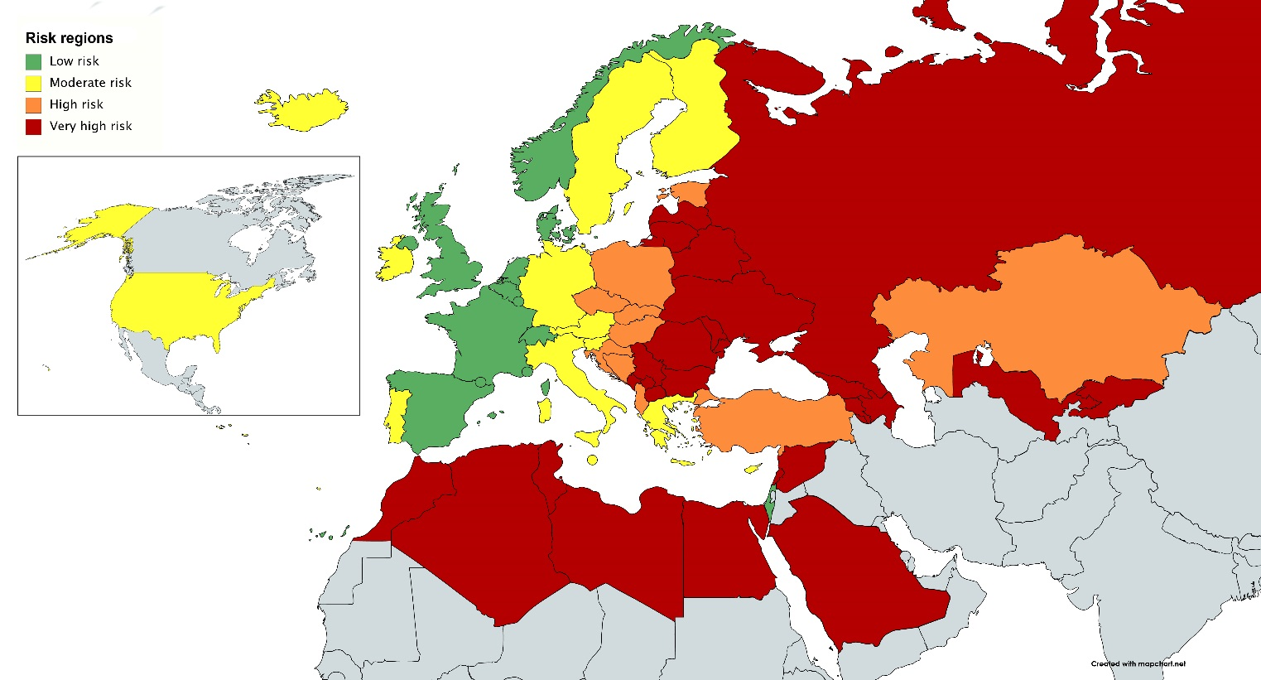
Countries were grouped into four risk regions according to their most recently reported WHO age- and sex-standardized overall CVD mortality rates per 100,000 population (ICD chapters 9, I00-I99). The four groupings were: low risk (<100 CVD deaths per 100,000), moderate risk (100 to <150 CVD deaths per 100,000), high risk (150 to <300 CVD deaths per 100,000), and very high risk (≥300 CVD deaths per 100,000).

Supplementary Figure 2: The relative effect of risk factors at different ages (black=male; red=female)
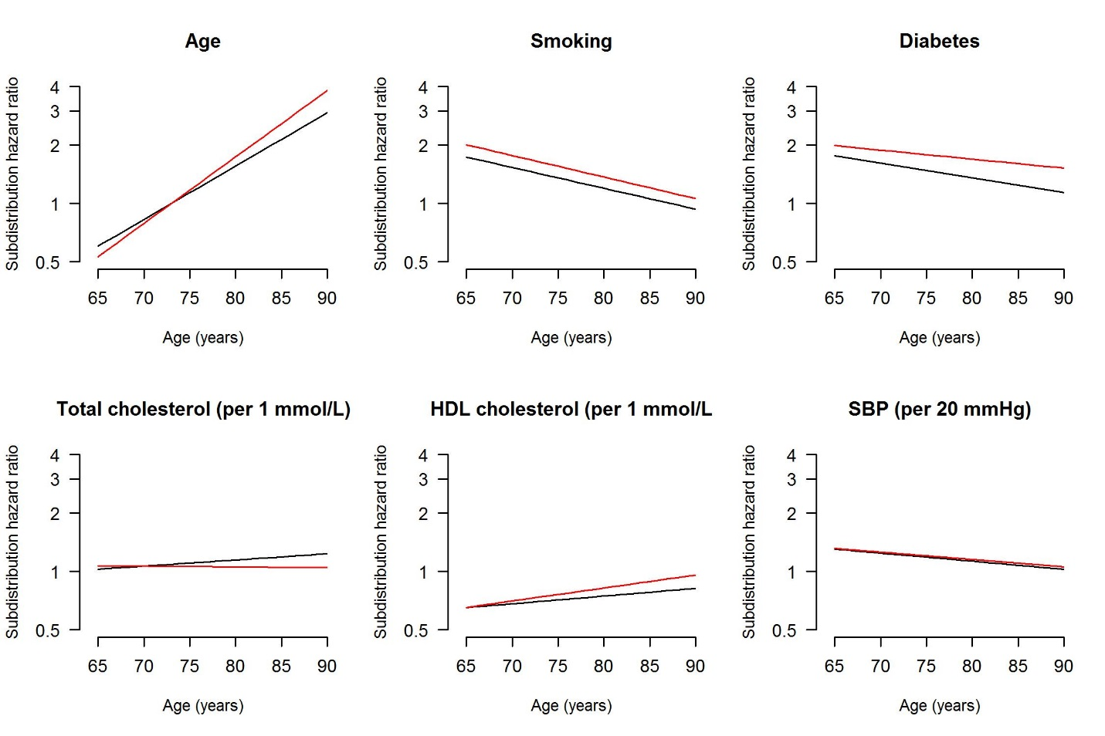

Supplementary Figure 3: Calibration plots of observed versus estimated risks in deciles of risk in the CONOR study population (internal validation) for (left) CVD event risk, and (right) CVD event risk including hospitalization for heart failure
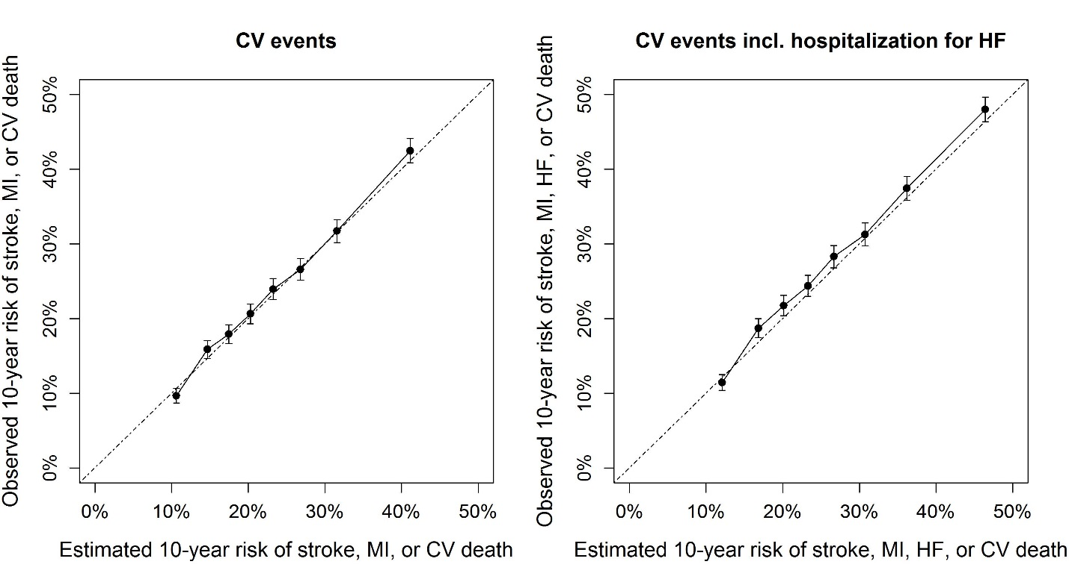

Supplementary Figure 4: Cardiovascular mortality and incidence in all risk regions in the entire middle-aged and older population.
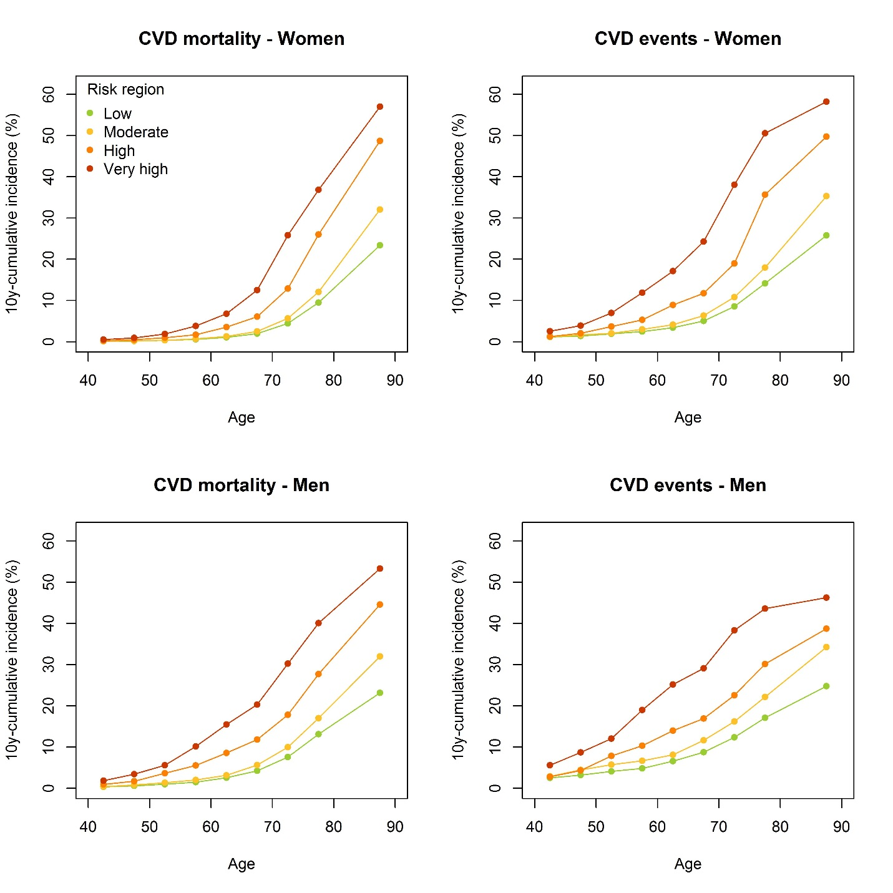
Regional age- and sex-specific CVD mortality rates (left) in the general population; regional age- and sex-specific CVD event rates in the primary prevention setting.

Supplementary Figure 5: Estimated CVD incidence rates and predicted risks
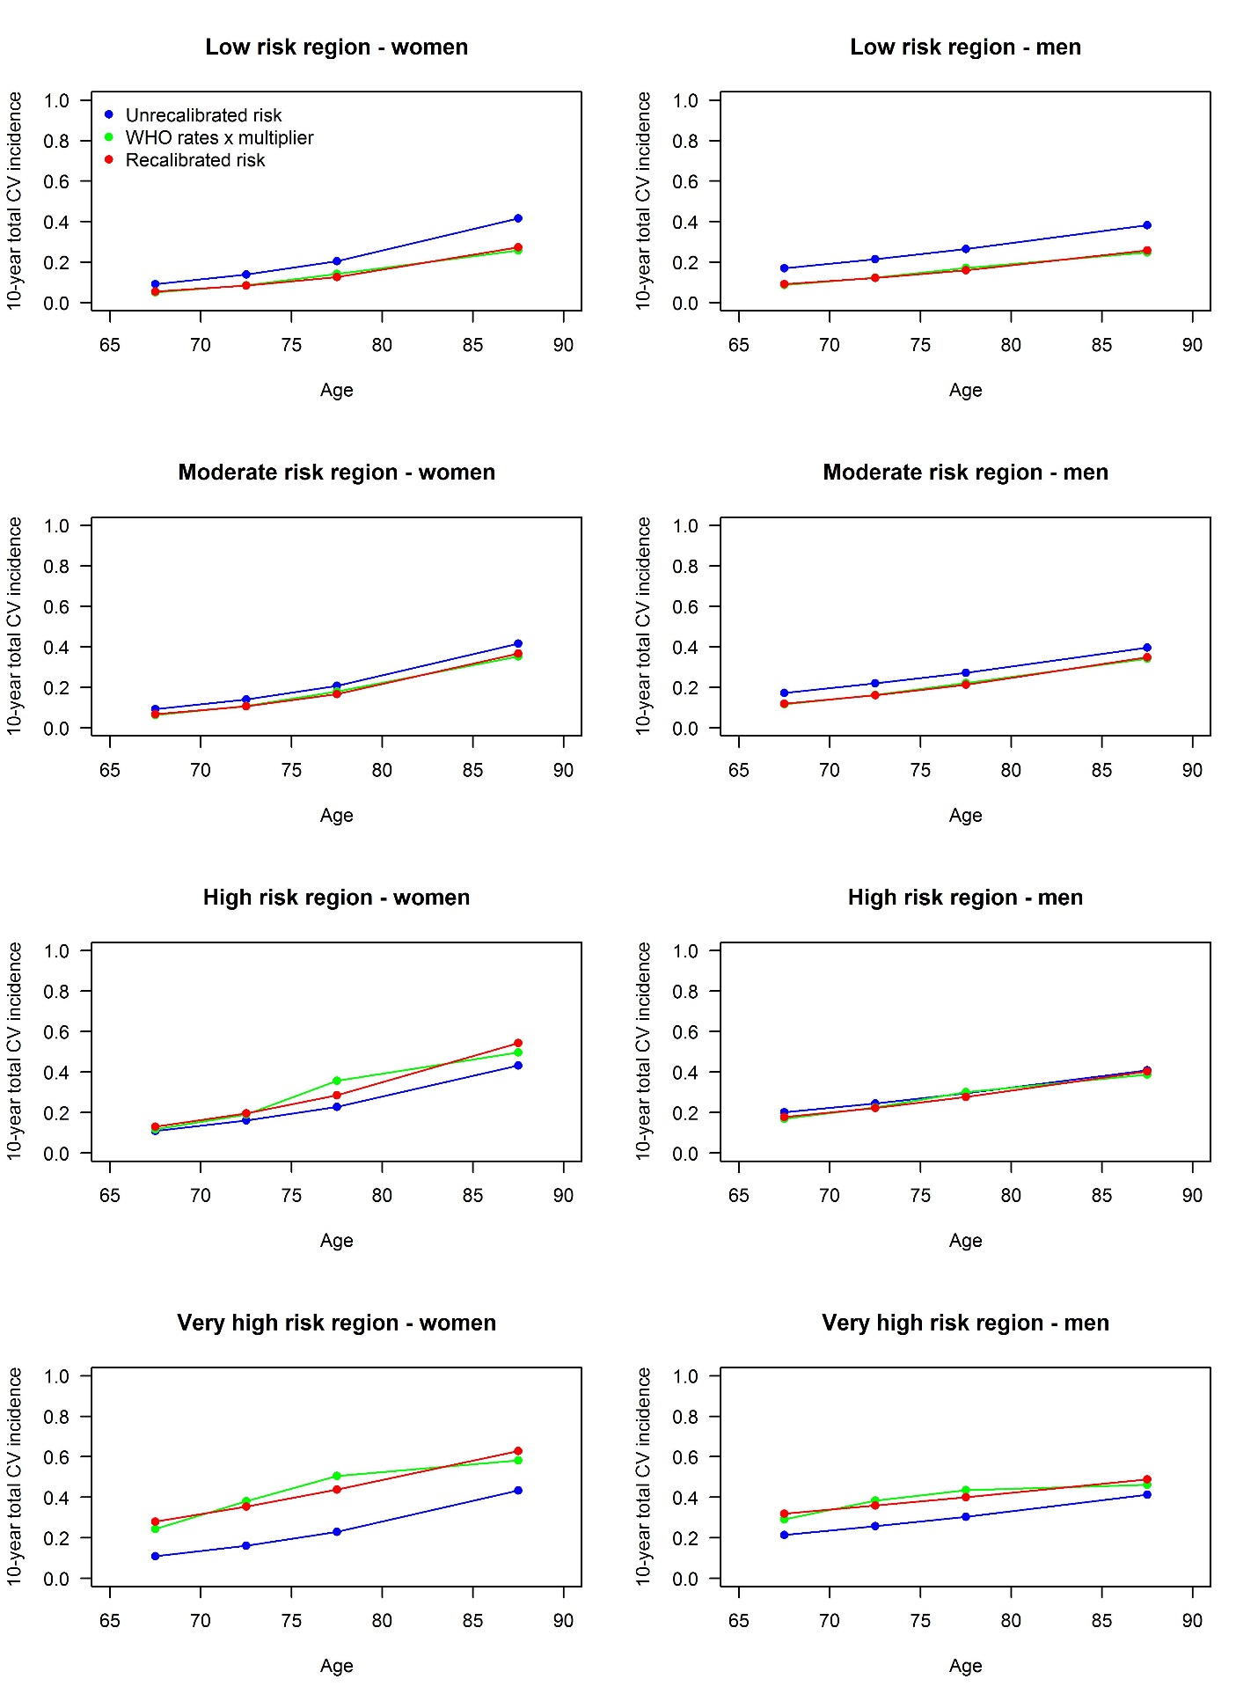

Supplementary Figure 6: Calibration plots of observed versus estimated (O/E) risks with O/E ratios within deciles of the external validation study populations. Risks were estimated for 3, 5, or 10 year time periods depending on available follow-up per study.
The estimated risks were recalibrated per study using the study-specific O/E ratio. The O/E ratio reflects the difference in baseline risk between the study population and risk region from which the study population comes, which may be affected due to participant selection and timeliness of the data.

Supplementary Figure 7: Age- and sex-specific distributions of fatal and non-fatal CVD risk in the four risk regions according to SCORE2-OP.
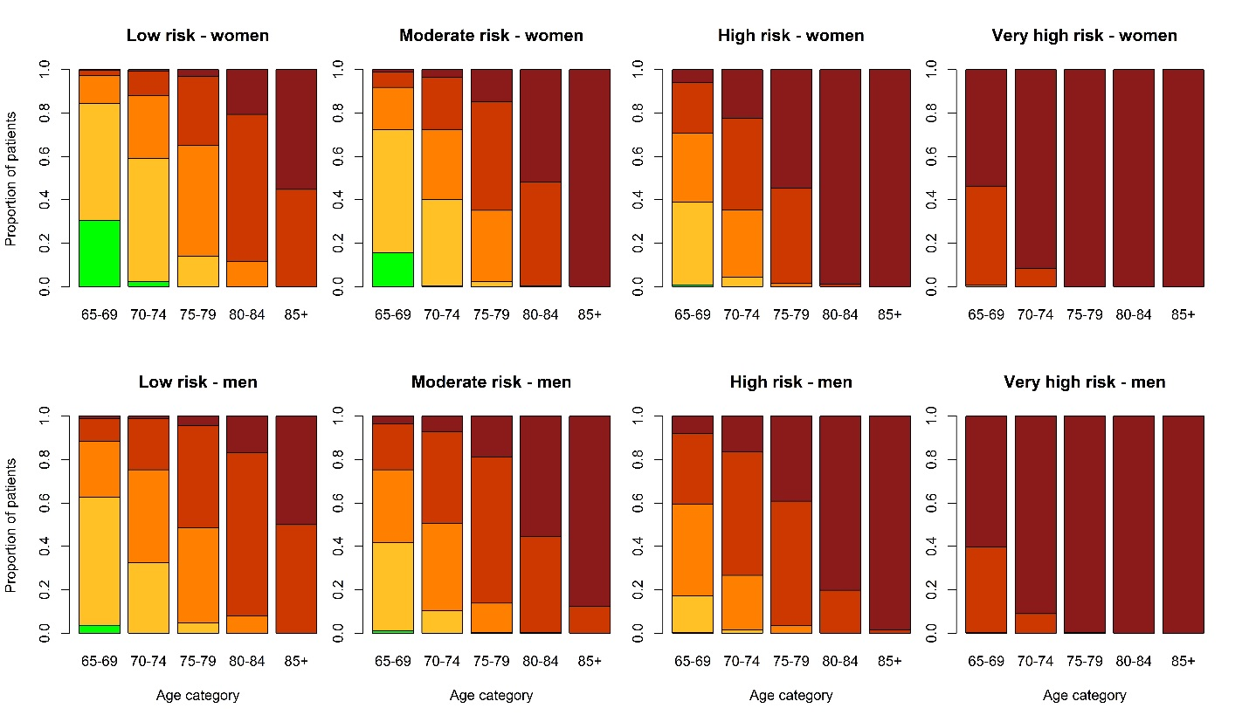
Age- and sex-specific risk distribution in the different risk regions, based on risk factor data in ARIC and MESA cohorts (n = 8,130).

Supplementary Figure 8: Risk charts of 5-year risk in all four risk regions

(sFig 10 cont.)

(sFig 10 cont.)

(sFig 10 cont.)

Supplementary Figure 9: SCORE2-OP predicted risks for given risk factors in all European regions
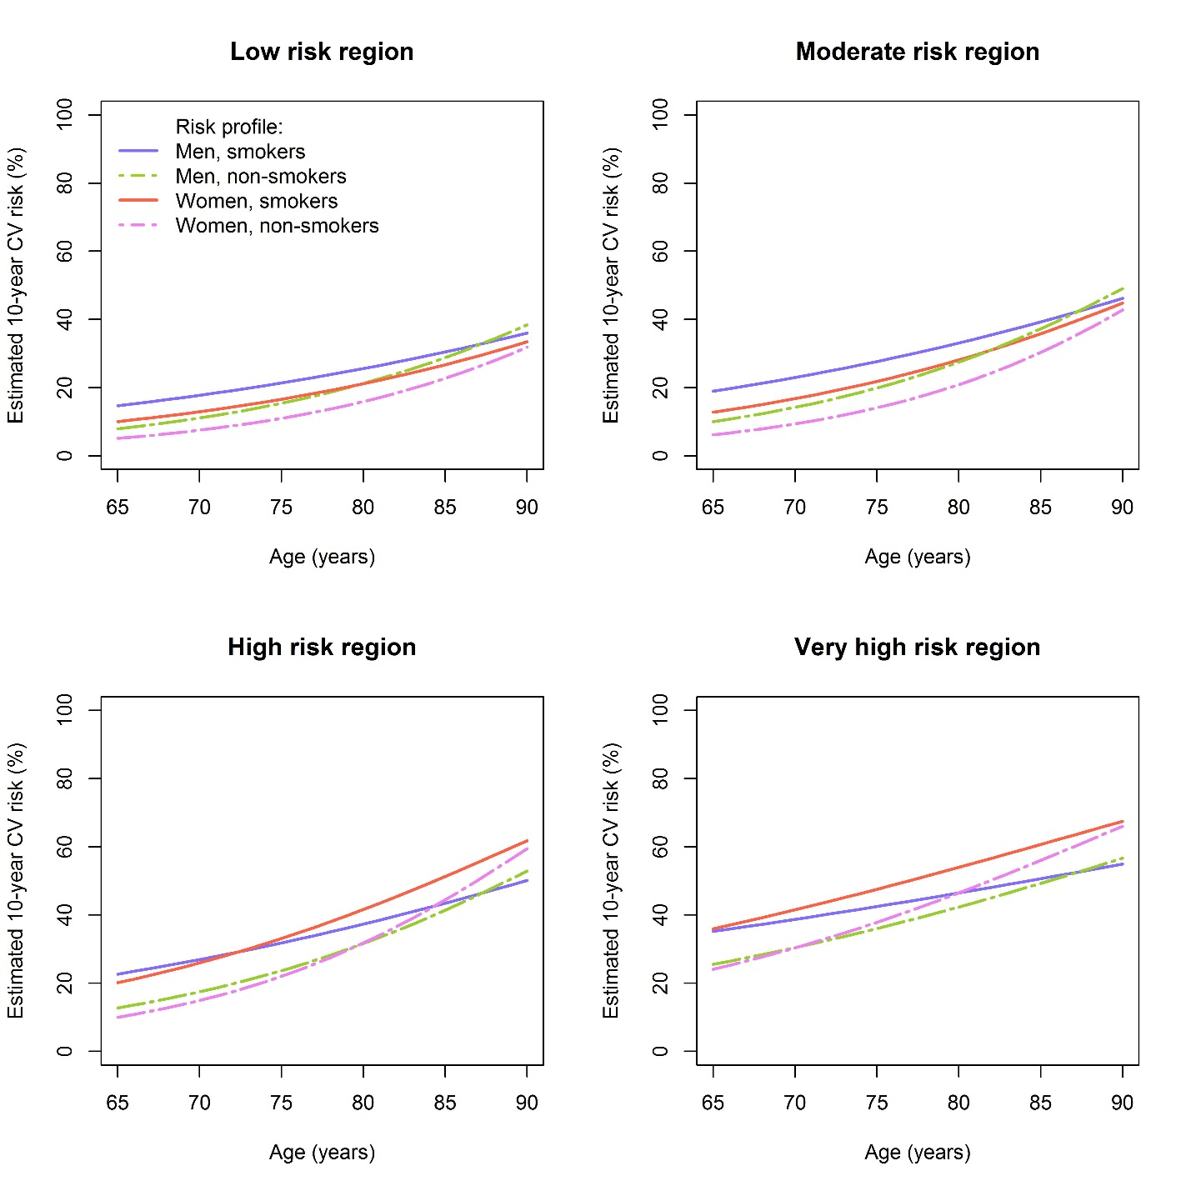

Predicted risks in all European regions for different risk profiles. Predictions for individuals with a non-HDL cholesterol of 4.5 mmol/l, and systolic blood pressure of 150mmHg, assuming no diabetes mellitus.

Supplementary Figure 10: Risk charts of 10-year risk in all four risk regions with uncertainty bounds based on the 95% CI of the risk model parameters

(sFig 10 cont.)

(sFig 10 cont.)

(sFig 10 cont.)

References used in supplementary material
1. Naess O, Søgaard AJ, Arnesen E, Beckstrøm AC, Bjertness E, Engeland A, Hjort PF, Holmen J, Magnus P, Njølstad I, Tell GS, Vatten L, Vollset SE, Aamodt G. Cohort profile: cohort of Norway (CONOR). Int J Epidemiol 2008;37:481–485.
2. Igland J, Tell G, Ebbing M, Nygard O, Vollset SE, Dimoski T. CVDNOR data and quality report: the CVDNOR project: cardiovascular disease in Norway 1994–2009. Description of data and data quality. Norway: University of Bergen; 2013.
3. Sulo G, Igland J, Vollset SE, Nygard O, Øyen N, Tell G. Cardiovascular disease and diabetes mellitus in Norway during 1994–2009: CVDNOR – a nationwide research project. Nor J Epidemiol 2013;23.
4. Govatsmark RES, Janszky I, Slørdahl SA, Ebbing M, Wiseth R, Grenne B, Vesterbekkmo E, Bønaa KH. Completeness and correctness of acute myocardial infarction diagnoses in a medical quality register and an administrative health register. Scand J Public Health 2020;48:5–13.
5. Øie LR, Madsbu MA, Giannadakis C, Vorhaug A, Jensberg H, Salvesen Ø, Gulati S. Validation of intracranial hemorrhage in the Norwegian Patient Registry. Brain Behav 2018;8:e00900.
6. Selmer R, Igland J, Ariansen I, Tverdal A, Njølstad I, Furu K, Tell GS, Klemsdal TO. NORRISK 2: A Norwegian risk model for acute cerebral stroke and myocardial infarction. Eur J Prev Cardiol 2017;24:773–782.
7. Cooney MT, Selmer R, Lindman A, Tverdal A, Menotti A, Thomsen T, DeBacker G, Bacquer D De, Tell GS, Njolstad I, Graham IM. Cardiovascular risk estimation in older persons: SCORE O.P. Eur J Prev Cardiol 2016;23:1093–1103.
8. The ARIC investigators. The Atherosclerosis Risk in Communities (ARIC) Study: design and objectives. Am J Epidemiol 1989;129:687–702.
9. Herrett E, Gallagher AM, Bhaskaran K, Forbes H, Mathur R, Staa T van, Smeeth L. Data Resource Profile: Clinical Practice Research Datalink (CPRD). Int J Epidemiol 2015;44:827–836.
10. Bulpitt C, Fletcher A, Beckett N, Coope J, Gil-Extremera B, Forette F, Nachev C, Potter J, Sever P, Staessen J, Swift C, Tuomilehto J. Hypertension in the Very Elderly Trial (HYVET): protocol for the main trial. Drugs Aging 2001;18:151–164.
11. Bild DE, Bluemke DA, Burke GL, Detrano R, Diez Roux A V, Folsom AR, Greenland P, Jacob DRJ, Kronmal R, Liu K, Nelson JC, O’Leary D, Saad MF, Shea S, Szklo M, Tracy RP. Multi-Ethnic Study of Atherosclerosis: objectives and design. Am J Epidemiol 2002;156:871–881.
12. Shepherd J, Blauw GJ, Murphy MB, Bollen ELEM, Buckley BM, Cobbe SM, Ford I, Gaw A, Hyland M, Jukema JW, Kamper AM, Macfarlane PW, Meinders AE, Norrie J, Packard CJ, Perry IJ, Stott DJ, Sweeney BJ, Twomey C, Westendorp RGJ. Pravastatin in elderly individuals at risk of vascular disease (PROSPER): a randomised controlled trial. Lancet 2002;360:1623–1630.
13. SPRINT Research Group, Wright J, Williamson J, Whelton P, Snyger J, Sink K, Rocco M, Reboussin D, Rahman M, Oparil S, Lewis C, Kimmel P, Johnson K, Goff DJ, Fine L, Cutler J, Cushman W, Cheung A, Ambrosius W. A Randomized Trial of Intensive versus Standard Blood-Pressure Control. N Engl J Med 2015;373:2103–2116.
14. Williamson JD, Supiano MA, Applegate WB, Berlowitz DR, Campbell RC, Chertow GM, Fine LJ, Haley WE, Hawfield AT, Ix JH, Kitzman DW, Kostis JB, Krousel-Wood MA, Launer LJ, Oparil S, Rodriguez CJ, Roumie CL, Shorr RI, Sink KM, Wadley VG, Whelton PK, Whittle J, Woolard NF, Wright JTJ, Pajewski NM. Intensive vs Standard Blood Pressure Control and Cardiovascular Disease Outcomes in Adults Aged >/=75 Years: A Randomized Clinical Trial. JAMA 2016;315:2673–2682.
15. SCORE2 Working Group. European Society of Cardiology SCORE2 risk prediction algorithms: revised models to estimate 10-year risk of cardiovascular disease in Europe. Under review.
16. Conroy RM, Pyörälä K, Fitzgerald AP, Sans S, Menotti A, Backer G De, Bacquer D De, Ducimetière P, Group on behalf of the S project, Jousilahti P, Keil U, Njølstad I, Oganov RG, Thomsen T, Tunstall-Pedoe H, Tverdal A, Wedel H, Whincup P, Wilhelmsen L, Graham IM, on behalf of the SCORE project group. Estimation of ten-year risk of fatal cardiovascular disease in Europe: the SCORE project. Eur Heart J 2003;24:987–1003.
17. Kaasenbrood L, Bhatt DL, Dorresteijn JA, Wilson PW, D’Agostino RB, Massaron JM, Graaf Y van der, Cramer MJ, Kappelle LJ, Borst GJ de, Steg PG, Visseren FL. Estimated life-expectancy without recurrent cardiovascular events in patients with vascular disease: the SMART-REACH model. J Am Heart Assoc 2018;7:e009217.
18. Dorresteijn JAN, Visseren FLJ, Ridker PM, Wassink AMJ, Paynter NP, Steyerberg EW, Graaf Y van der, Cook NR. Estimating treatment effects for individual patients based on the results of randomised clinical trials. BMJ 2011;343:d5888.
19. Ludvigsson JF, Andersson E, Ekbom A, Feychting M, Kim J-L, Reuterwall C, Heurgren M, Olausson PO. External review and validation of the Swedish national inpatient register. BMC Public Health BioMed Central Ltd; 2011;11:450.
20. Leitsalu L, Haller T, Esko T, Tammesoo M-L, Alavere H, Snieder H, Perola M, Ng PC, Mägi R, Milani L, Fischer K, Metspalu A. Cohort Profile: Estonian Biobank of the Estonian Genome Center, University of Tartu. Int J Epidemiol 2015;44:1137–1147.
21. Peasey A, Bobak M, Kubinova R, Malyutina S, Pajak A, Tamosiunas A, Pikhart H, Nicholson A, Marmot M. Determinants of cardiovascular disease and other non-communicable diseases in Central and Eastern Europe: Rationale and design of the HAPIEE study. BMC Public Health 2006;6:255.
22. Pennells L, Kaptoge S, Wood A, Sweeting M, Zhao X, White I, Burgess S, Willeit P, Bolton T, Moons KGM, Schouw YT van der, Selmer R, Khaw K-T, Gudnason V, Assmann G, Amouyel P, Salomaa V, Kivimaki M, Nordestgaard BG, Blaha MJ, Kuller LH, Brenner H, Gillum RF, Meisinger C, Ford I, Knuiman MW, Rosengren A, Lawlor DA, Volzke H, Cooper C, et al. Equalization of four cardiovascular risk algorithms after systematic recalibration: individual-participant meta-analysis of 86 prospective studies. Eur Heart J 2019;40:621–631.
23. Ettehad D, Emdin CA, Kiran A, Anderson SG, Callender T, Emberson J, Chalmers J, Rodgers A, Rahimi K. Blood pressure lowering for prevention of cardiovascular disease and death: a systematic review and meta-analysis. Lancet 2016;387:957–967.
24. Beckett NS, Peters R, Fletcher AE, Staessen JA, Liu L, Dumitrascu D, Stoyanovsky V, Antikainen RL, Nikitin Y, Anderson C, Belhani A, Forette F, Rajkumar C, Thijs L, Banya W, Bulpitt CJ. Treatment of hypertension in patients 80 years of age or older. N Engl J Med 2008;358:1887–1898.
25. Baigent C, Blackwell L, Emberson J, Holland LE, Reith C, Bhala N, Peto R, Barnes EH, Keech A, Simes J, Collins R, Lemos J De, Braunwald E, Blazing M, Murphy S, Downs JR, Gotto A, Clearfield M, Holdaas H, Gordon D, Davis B, Koren M, Dahlof B, Poulter N, Sever P, Knopp RH, Fellström B, Holdaas H, Jardine A, Schmieder R, et al. Efficacy and safety of more intensive lowering of LDL cholesterol: A meta-analysis of data from 170 000 participants in 26 randomised trials. Lancet Elsevier Ltd; 2010;376:1670–1681.
26. Blood Pressure Lowering Treatment Trialists’ Collaboration. Blood pressure-lowering treatment based on cardiovascular risk: a meta-analysis of individual patient data. Lancet England; 2014;384:591–598.
27. Cholesterol Treatment Trialists’ Collaboration. Efficacy and safety of statin therapy in older people: a meta-analysis of individual participant data from 28 randomised controlled trials. Lancet 2019;393:407–415.
28. Kent DM, Steyerberg E, Klaveren D van. Personalized evidence based medicine: predictive approaches to heterogeneous treatment effects. BMJ 2018;363:k4245.

